Date : Approved by :

ASSIGNMENT : ITC-EDU-AS-1803-S-018-0413 Sheet : 1 OF 1

Course : V-CPRG Batch No. :

Module : “C” Language(Calculation) Type : Theory

Date of Issue : Date of Submission :

1) Find the area :

1. area of triangle : ½ \* b \* h b=base of triangle, h=height of triangle
2. b=5 h=10
3. b=4.5 h=3.5

h

1. b=2.5 h=5

1. 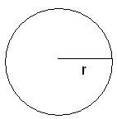area of circle : Pi \* r2 Pi=3.14
2. r=5
3. r=4.5
4. r=2.5

r= radious of circle

1. area of trapezoid ½ ( a+b ) \* h a & b are length of parallel side of trapezoid

h is attitude of trapezoid

1. 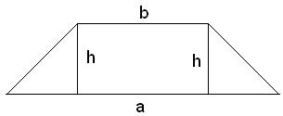a=5 b=5 h=2.5
2. a=4.5 b=1.2 h=2
3. a=0.5 b=2 h=4

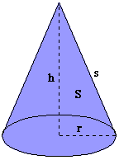

1. Total Surface area of cone= Pi \* r \* ( r + s ) r=radius of base,
2. height, Pi=3.14 s=slant
3. r=5 s=5
4. r=4.5 s=1.2
5. r=0.5 s=2

ASSIGNMENT : ITC-EDU-AS-1803-S-018-0413 Sheet : 1 OF 1

Course : V-CPRG Batch No. :

Module : “C” Language Type : Theory

Date of Issue : Date of Submission :

Date : Approved by :

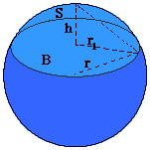5) Calculate the volume of spherical cap r=radius of sphere, r1=radius of base:   
 h=height, Pi=3.14

V = (Pi/6)\*(3\*r12+h2)\*h

1. r1=5 h=4
2. r1=4.5 h=1
3. r1=0.5 h=1

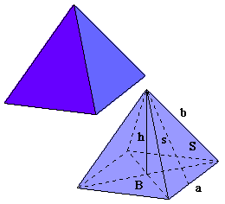6) Calculate total surface area of a pyramid a= Side of base, b=other edges

Total surface area = a ( 2s+a )

s=sqrt(b2 – a2/4)

1. b=5 a=4
2. b=4.5 a=2
3. b=2.5 a=1

7) calculate total surface area of rectangular parallelepiped a,b,c=edges of parallelepiped

Area = 2 ( ab + ac + bc )

1. a=5 b=4

c

1. a=4.5 b=2

d

1. a=2.5 b=1 b a

a